Week 7 :-
13. React-HOL :-
Code:--
BooDetails.js :-
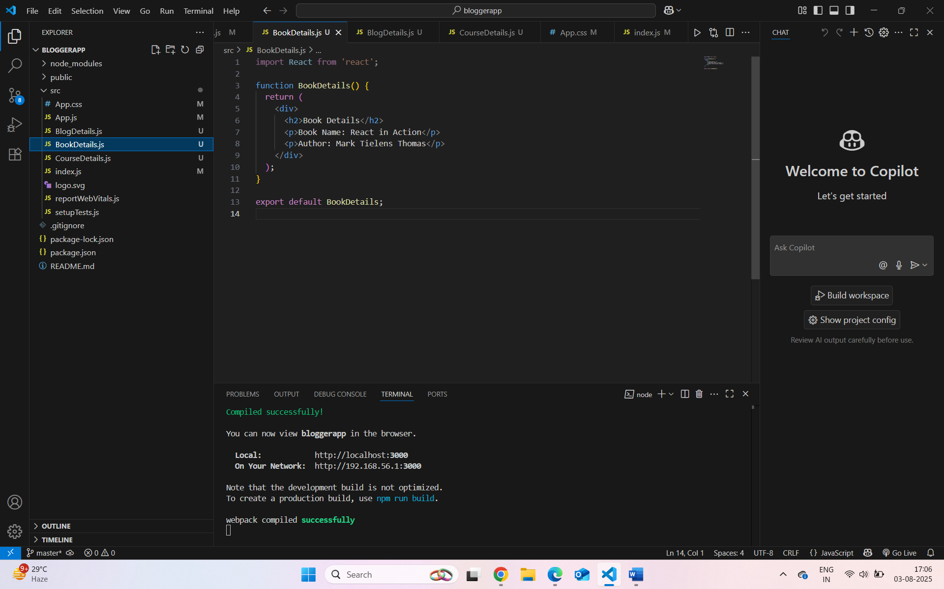
BlogDetails.js :-
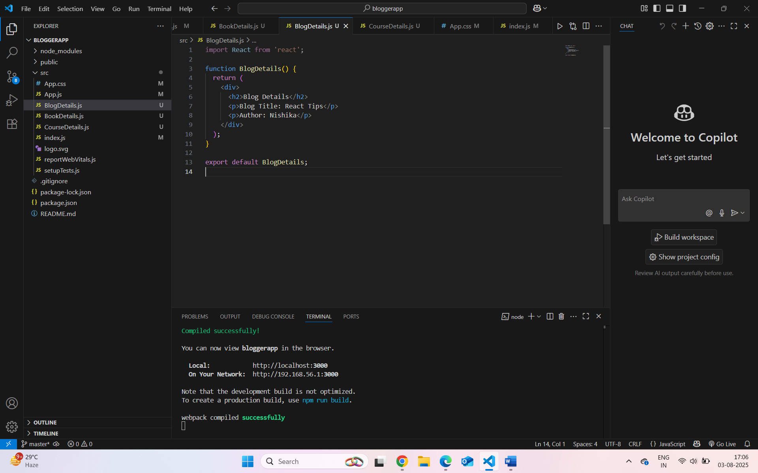

CourseDetails.js :-
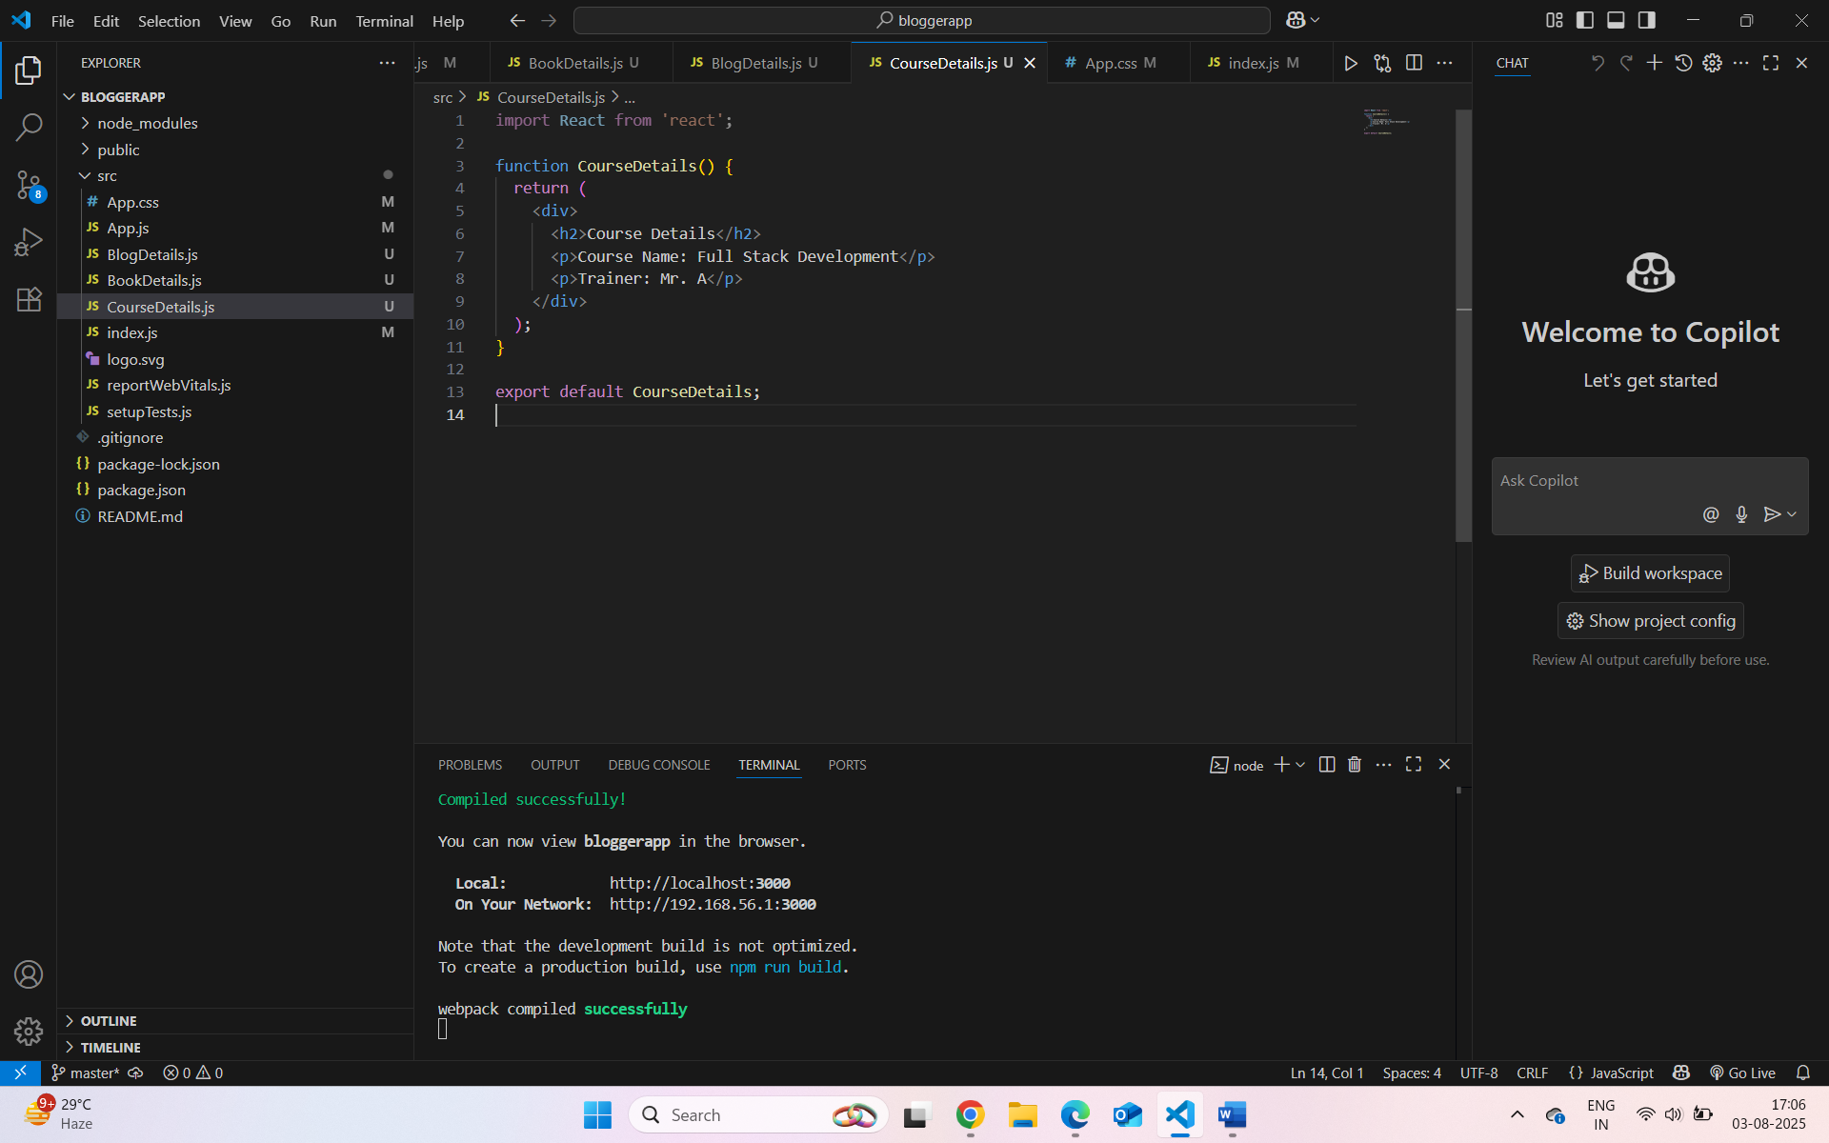
App.js :-
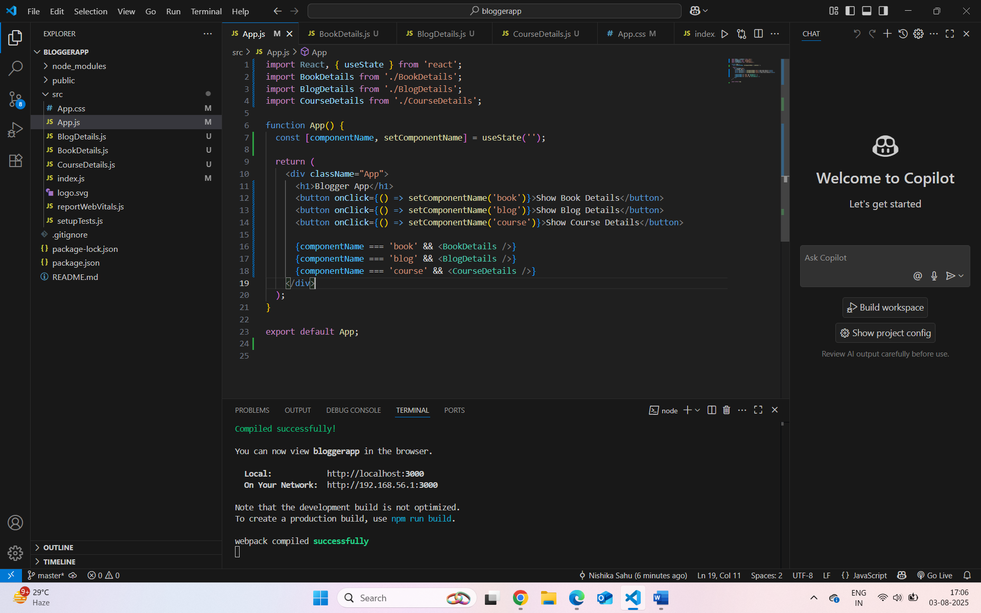

App.css :-
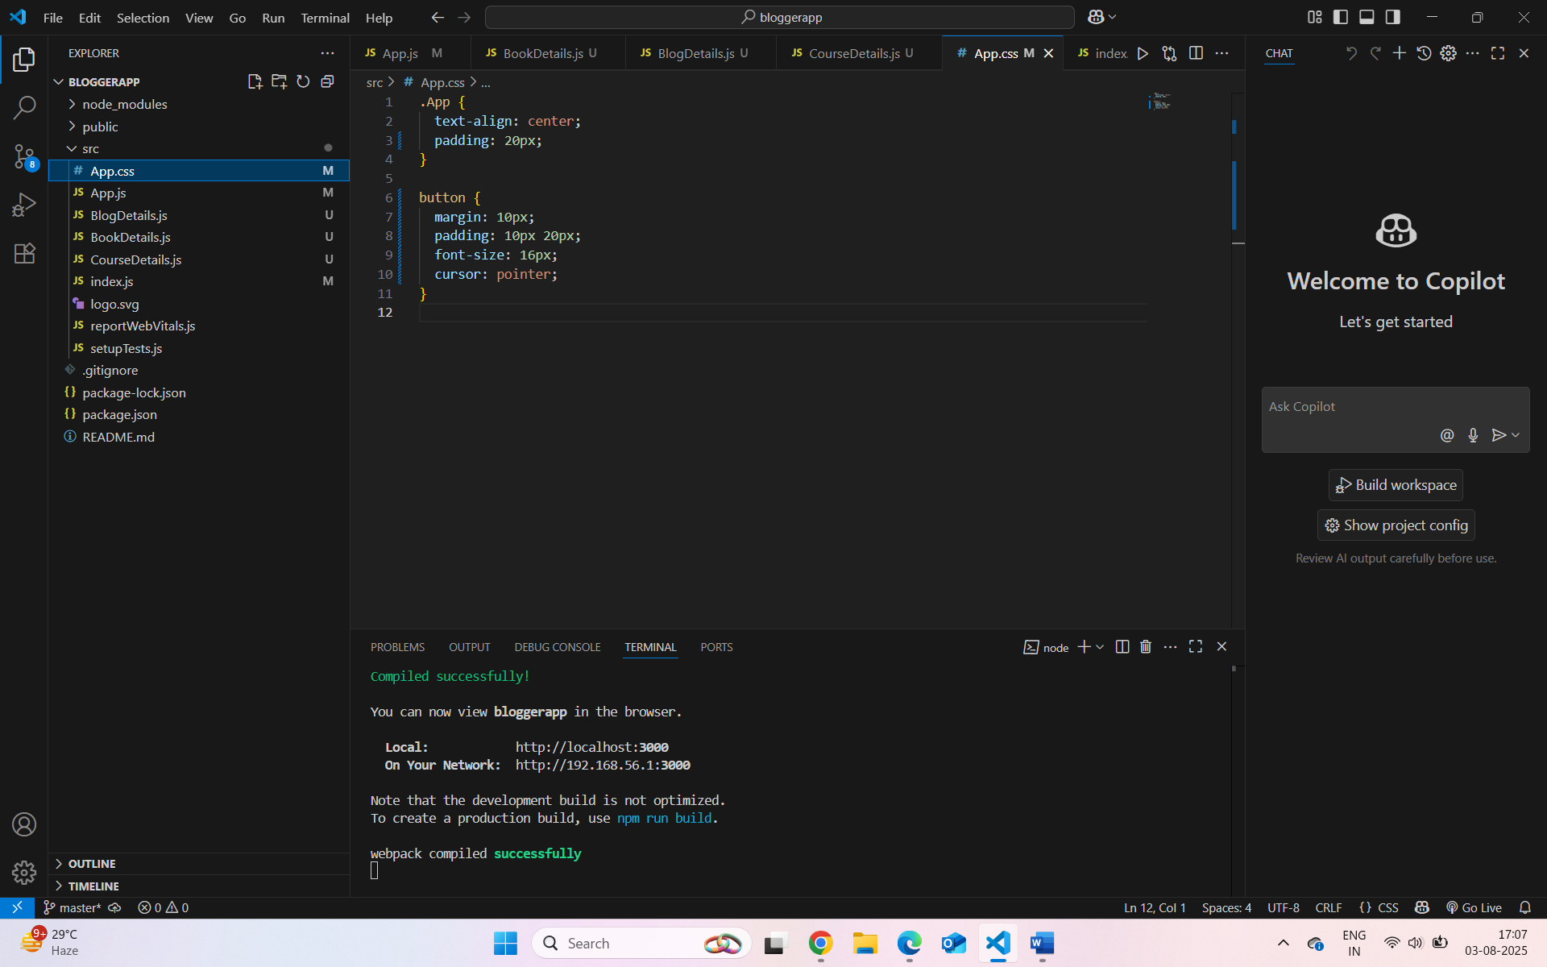
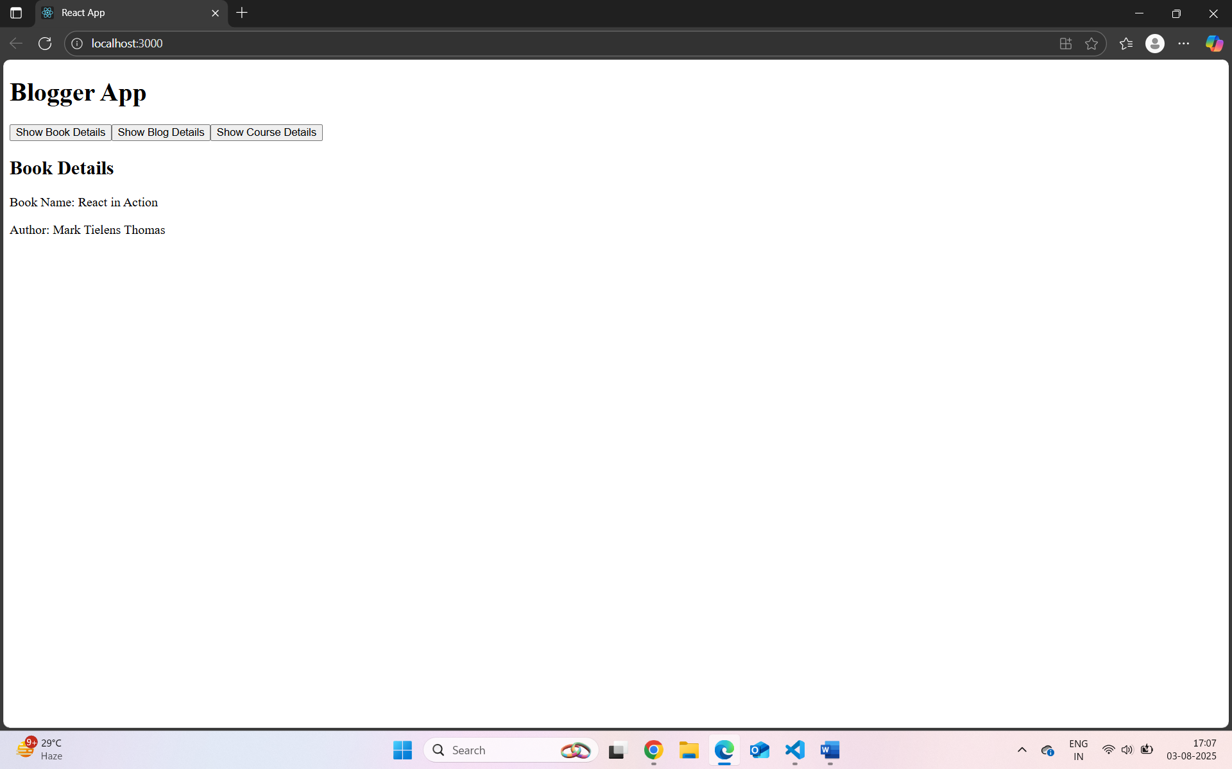
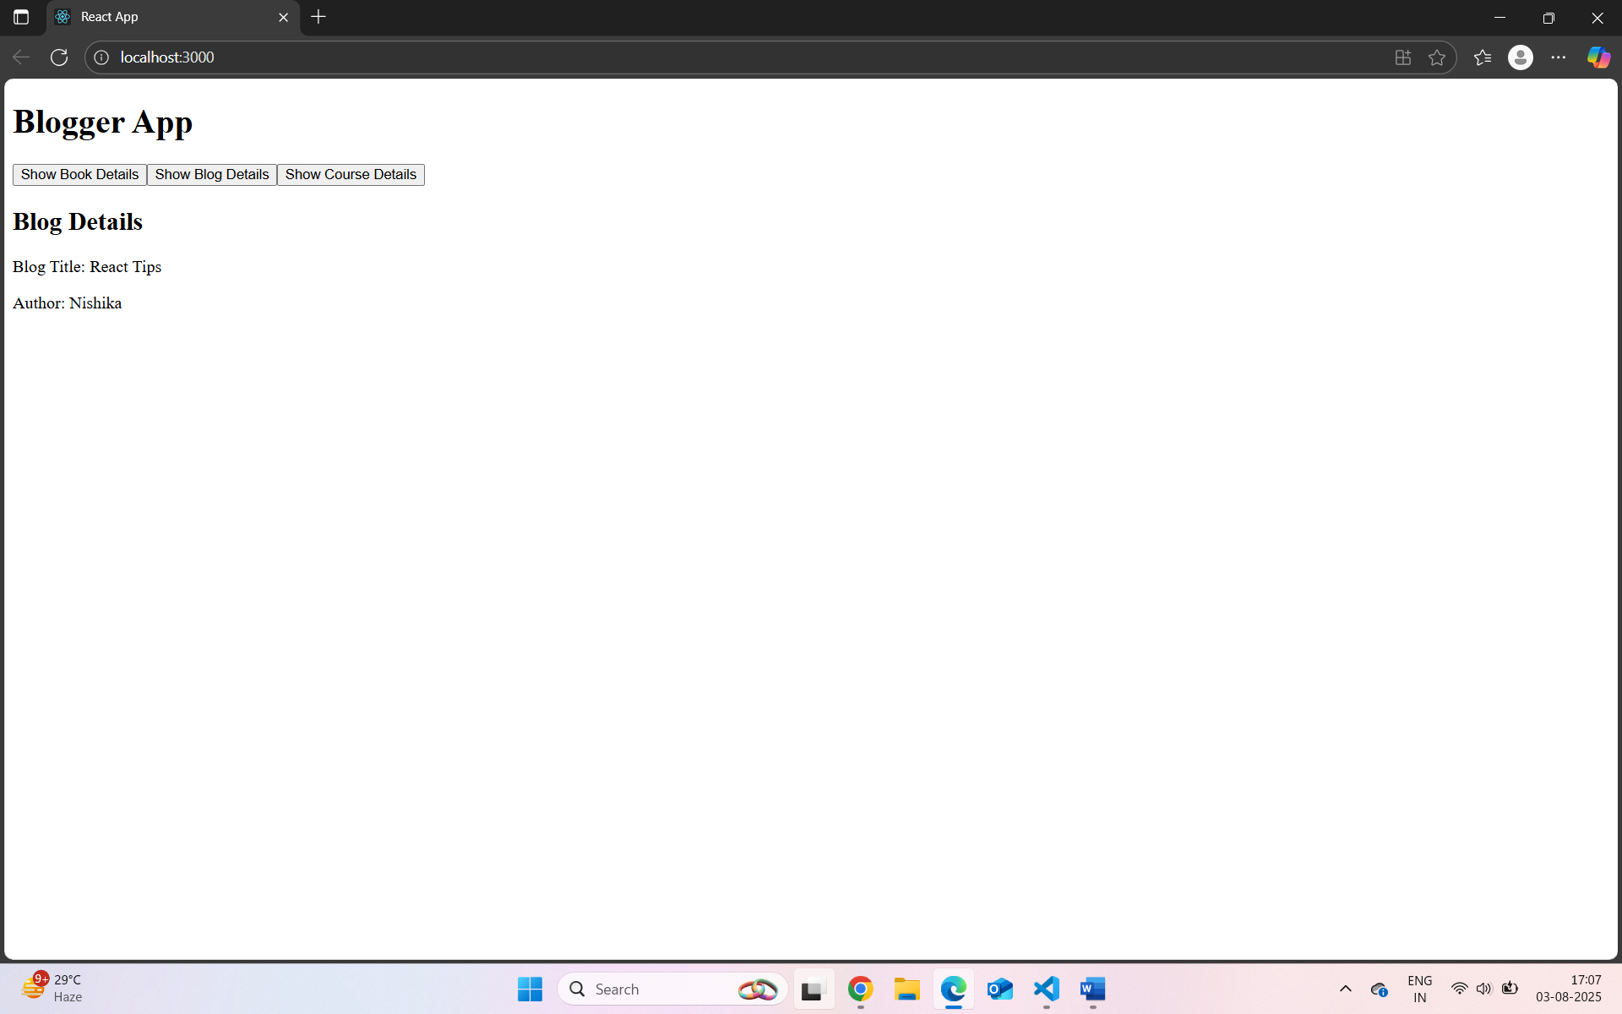
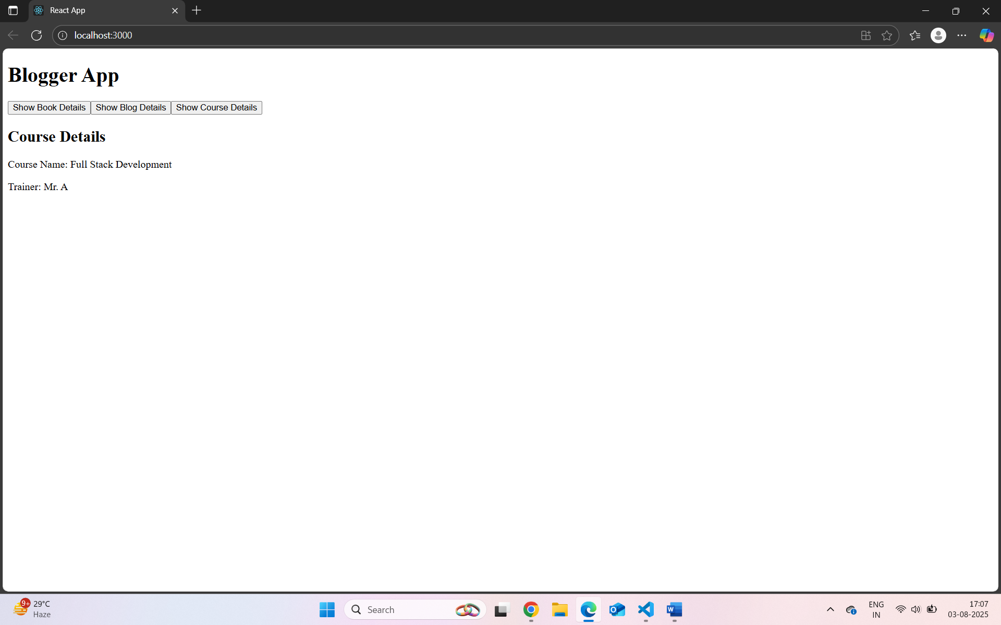
More possible ways to rending with App.js code:-
Using Ternary Operator
function App() {
const [componentName, setComponentName] = useState('');
return (
<div>
<h1>Blogger App</h1>
<button onClick={() => setComponentName('book')}>Book</button>
<button onClick={() => setComponentName('blog')}>Blog</button>
<button onClick={() => setComponentName('course')}>Course</button>
{
componentName === 'book' ? <BookDetails /> :
componentName === 'blog' ? <BlogDetails /> :
componentName === 'course' ? <CourseDetails /> :
null
}
</div>
);
}
Using switch Statement :-
function App() {
const [componentName, setComponentName] = useState('');

const renderComponent = () => {
switch (componentName) {
case 'book':
return <BookDetails />;
case 'blog':
return <BlogDetails />;
case 'course':
return <CourseDetails />;
default:
return null;
}
};

return (
<div>
<h1>Blogger App</h1>
<button onClick={() => setComponentName('book')}>Book</button>
<button onClick={() => setComponentName('blog')}>Blog</button>
<button onClick={() => setComponentName('course')}>Course</button>

{renderComponent()}
</div>
);
}
Using if Statement:-
function renderComponent(name) {
if (name === 'book') return <BookDetails />;
if (name === 'blog') return <BlogDetails />;
if (name === 'course') return <CourseDetails />;
return null;
}

function App() {
const [componentName, setComponentName] = useState('');

return (
<div>
<h1>Blogger App</h1>
<button onClick={() => setComponentName('book')}>Book</button>
<button onClick={() => setComponentName('blog')}>Blog</button>
<button onClick={() => setComponentName('course')}>Course</button>

{renderComponent(componentName)}
</div>
);
}

